Furniture Planner Read me

To deploy this web application, you need to perform the following steps:

1. You need to Install MYSQL Server 5.7 or above. Here is a link to the manual on how to do it step by step (<https://dev.mysql.com/doc/mysql-installation-excerpt/5.5/en/windows-install-archive.html>)
2. Install Glassfish Server 3.1 or above. Here is a link to the manual on how to do it step (<https://docs.oracle.com/cd/E26576_01/doc.312/e24935/installing.htm#GSING00002> )
3. Copy the MYSQL driver jar that is contained in the repository ~\FurniturePlanner\database\ mysql-connector-java-5.1.46.jar and place it on the Glassfish Server installation under the lib folder, like this glassfish3\glassfish\lib
4. Connect to the admin console of Glassfish Server, usually <http://localhost:4848> and on the left side under resources you are going to find JDBC and inside it JDBC Resources and Connection pools JDBC like in the next figure.



1. Create a connection pool like in the image

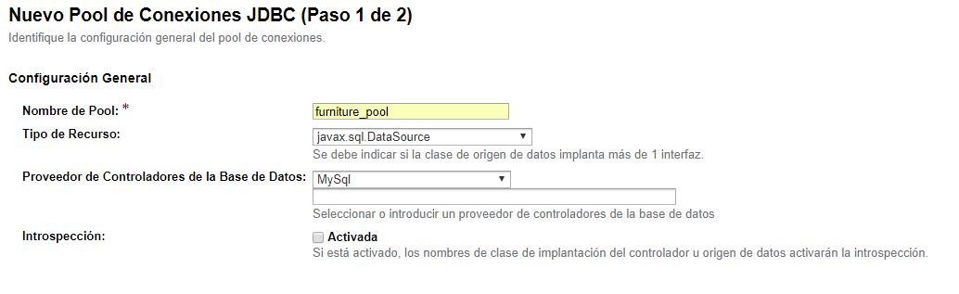

1. Setup the properties of the database

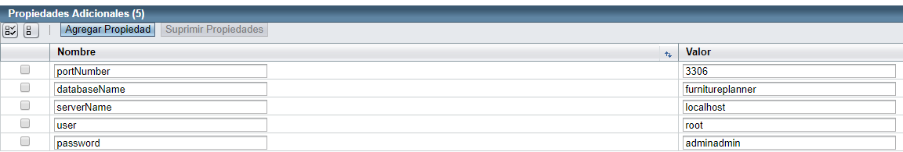

1. To validate that the pool is setup correctly on the general tab click “Ping” like in the image 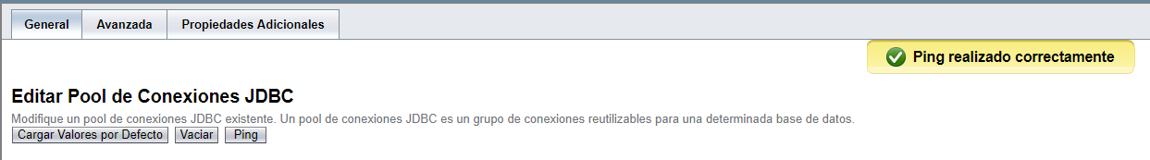
2. Once the connection pool is setup properly, we are going to the JDBC resources and we are creating a new Resource with the specified JNDI Name and select the pool that we just created.

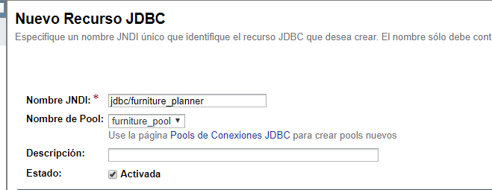

1. Setting up the database scripts, on our repository you can find under the folder ~\FurniturePlanner\database\ 4 scripts that need to be executed on the database in the following order.
   * 1. FurniturePlannner.sql
     2. sp_get_clients_by_name.sql
     3. sp_get_orders_by_name.sql
     4. sp_util_string_split.sql
2. The web application is on the repository under the folder ~\FurniturePlanner\readme and installer\FurniturePlanner.war, we are going to select this file on the next screen and click accept.

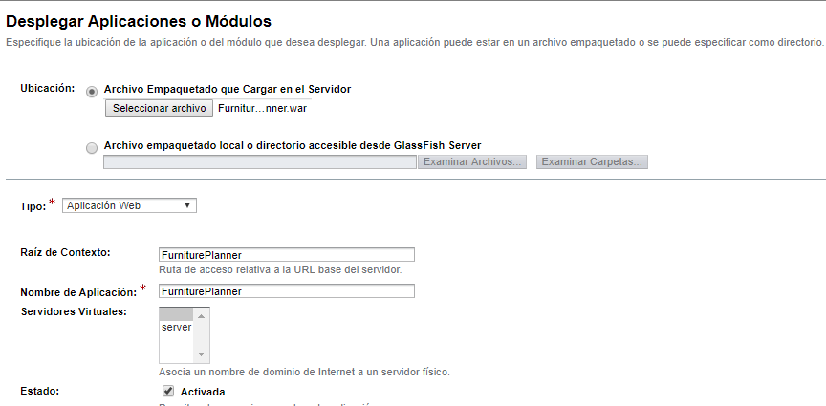

1. On the left side of the GlassFish admin console it should look like this.



1. The application should be running and ready now so to test it here is the local link <http://localhost:8080/FurniturePlanner/intro.jsp> Enjoy!